|  |  |
| --- | --- |
|  | **2023** |
|  | * Bright Health Solutions Society * GA International * FDM Group   BAO, Qingjun |

|  |
| --- |
| **[Careers and jobs]** |
| *The search results of Full Stack Development job titles* |

Table of Contents

Job Title: Full Stack Developer 1

Company Name: Bright Health Solutions Society 1

Job Title: Full Stack Developer 2

Company Name: GA International 2

Job Title: Junior Software Developer 3

Company Name: FDM Group 3

# Job Title: Full Stack Developer

## Company Name: Bright Health Solutions Society

#### Location: 467 Queen St E, Toronto, ON M5A 1T9

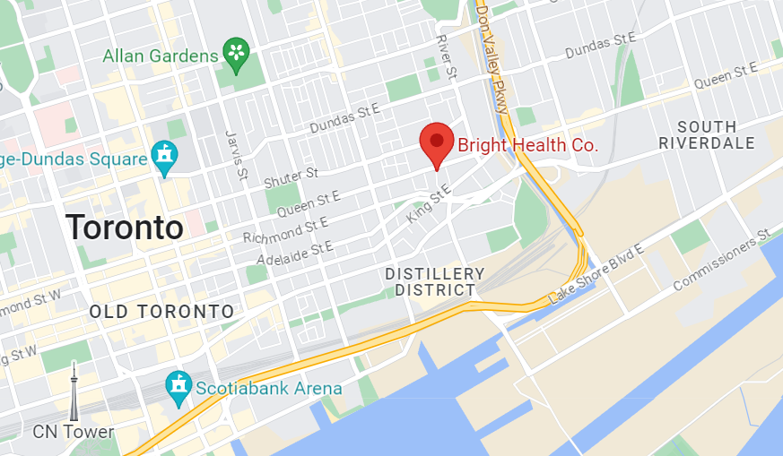

#### Reason why you might recommend this job:

Bright Health is a company that sparks innovation and change within the healthcare industry. They specialize in creating and developing software products and solutions that prioritize exceptional experiences for both patients and providers. By assisting their clients, Bright Health enables them to provide top-notch patient care and enhance overall outcomes. Additionally, they display a genuine concern for the future of healthcare in Canada. So I think in the medical industry, this is an excellent company.

#### URL:

<https://ca.indeed.com/cmp/Bright-Health-Solutions-Society/jobs?jk=57c256f468b4df57>

#### Job Description:[1]

**Duties and Responsibilities:**

* Working with other team members, partners, and customers to understand requirements.
* Working with local and remote technical and support staff to estimate, design, implement, test and debug changes and extensions to Bright Health’s products.
* Participating in agile development activities including release planning, sprint planning, daily stand-ups, and sprint and code reviews.
* Supporting customers by debugging issues.

**Qualifications and Requirements:[2]**

* Expert in React, Typescripts and single page applications.
* ASP.NET (ideally ASP.NET Core) experience.
* SQL database experience.
* A strong quality ethic.
* Consistent follow through on the completion of tasks in a timely manner.

# Job Title: Full Stack Developer

## Company Name: GA International

#### Location: 4455 Rue Louis-B.-Mayer, Laval, QC H7P 6B5

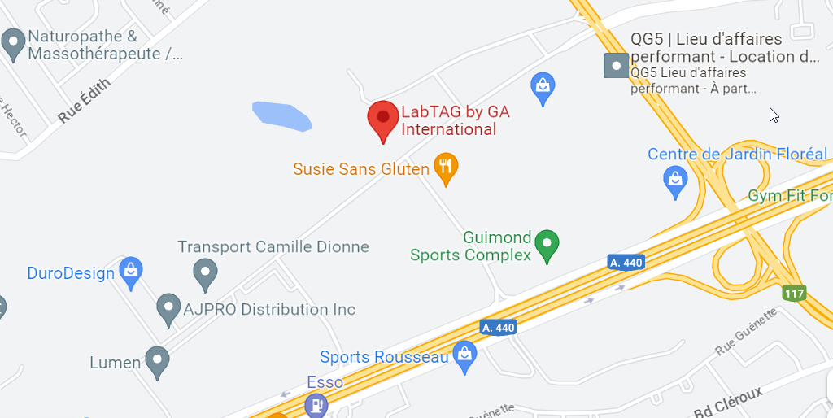

#### Reason why you might recommend this job:

GA International has established itself as a prominent figure in the industry in the past two decades. They provide comprehensive laboratory labelling solutions to academic, government, and commercial sectors. Their headquarters is situated in Laval, QC, while they also operate locally in the United States, the Netherlands, and the United Kingdom. I believe that it's a quality enterprise which I could reliance.

#### URL:

<https://ca.indeed.com/cmp/Ga-International-2/jobs?jk=d93e25fb99d411f9>

#### Job Description:[3]

**Responsibilities:[4]**

* Develop, test, and deploy high-quality applications.
* Design and develop SSRS reports for data visualization and reporting requirements.
* Participate in the entire software development lifecycle, including planning, design, implementation, testing, and maintenance.
* Work with SQL and MySQL databases, writing efficient queries.

**Requirements:**

* Bachelor's degree in Computer Science, Software Engineering, or a related field
* Proven experience working as a Full Stack Developer, with a successfully delivered projects.
* Expertise in back-end technologies such as .NET (C#).
* Strong knowledge of SQL and experience working with relational databases.
* Knowledge of version control systems (e.g., Git) and Agile development methodologies.

# Job Title: Junior Software Developer

## Company Name: FDM Group

#### Location: 1275 Av. des Canadiens-de-Montréal #500, Montréal, QC H3B 5E8

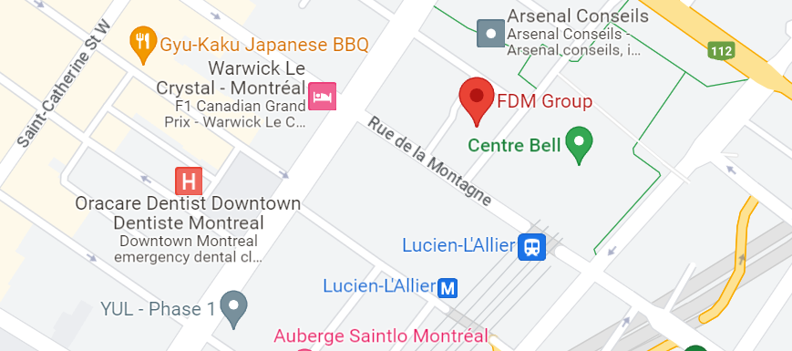

#### Reason why you might recommend this job:

With a remarkable track record spanning three decades, the FDM Career Development Program has been instrumental in propelling the professional growth of numerous individuals, including undergraduates, returners, and veterans worldwide. Through their Academy, they offer accelerated and specialized training that empowers participants with essential skills, enabling them to secure thrilling positions with renowned international clients so that this business has the potential to help me succeed.

#### URL: <https://ca.indeed.com/cmp/Fdm-Group/jobs?jk=4d5a4b5710067584>

#### Job Description:[5]

**Minimum Qualifications[6]**

* Degree or Diploma (preferably in Computer Science, Engineering, Mathematics, or similar)
* A natural aptitude for technology and a strong desire to expand your technical skill set.
* Exposure or familiarity with one or more programming languages (Python, JavaScript, Java, C, C++, C#).
* Exposure to one or more operating systems (Microsoft, Linux).
* Understanding of database and SQL.
* Able to commit to work for FDM for a minimum of two years working as an FDM consultant following the training period.
* Ability to communicate effectively in French (preferred) and English
* Eligible to work in Canada.

1. Quote from www.indeed.com
2. Job selected by my name: Qingjun BAO
3. Come from job platform www.indeed.com
4. Selected by the name: Qingjun
5. Quote from www.indeed.com
6. Job selected by Qingjun BAO